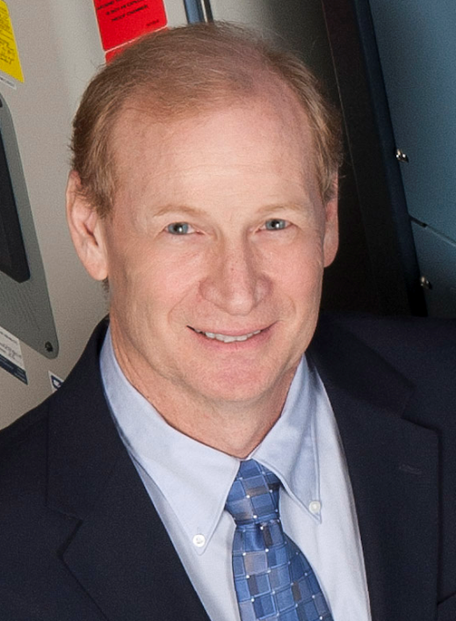
Robert (Bob) L. Galyen

Chief Technical Officer
Contemporary Amperex Technology Limited
Ningde City, Fujian Province, PRC

Chinese Government “Friendship Award”
“National Distinguished Expert” China 1000 Program
SAE Chairman Battery Standards Steering Committee
President NAATBatt International
Dean’s Executive Advisory Board Ball State University

Robert (Bob) L. Galyen, age 61, is recognized as one of the top executives in the energy storage world with experience in technology and business operations of small and large corporations. He currently holds the position Chief Technical Officer of Contemporary Amperex Technology Limited, both located in NingDe City, Fujian Province in The People’s Republic of China. Bob is the Chairman of the SAE International Battery Standards Steering Committee with 22 Committees reporting to him. He also serves as Liaison to the MVC and China Automotive Advisory Councils for SAE International. Currently Bob is the President of NAATBatt International, a trade association specific to the battery industry. He serves on two non-profit organizations including Lugar Center for Renewable Energy Advisory Board at IUPUI and the Dean’s Executive Advisory Council of Ball State University. Bob’s education includes a Master’s degree in Chemistry, with Bachelor’s degrees in Chemistry and Biology from Ball State University. His 38 years’ work experience in battery technology, manufacturing and business operations has given him unique perspective on worldwide business, making him uniquely qualified as an energy storage spokesperson globally. Bob sits on 5 Board of Directors of corporations within the USA. He is the recipient of numerous awards including; the Automotive News “Electrifying 100,” the SAE International Technical Standards Board “Outstanding Contribution Award,” Ball State University “Circle of Excellence Award,” the NFPA Fire Protection Research Foundation’s “Foundation Medal,” General Motors “Best of the Best” award, the Chinese “1000 Talent Plan Award” and most recently the Chinese Government Friendship Award. Bob’s expertise has afforded him many public speaking opportunities worldwide. He was the first person to have been featured on the front cover of Batteries International.

Brief Bio: July 2016
Galyen brief bio 20160724.docx

